YOU, YOUR HORSE AND COUNTRY
Equine Salt Therapy is the modality I have developed as proof of concept of my global patent for “Livestock Treatment Method and Apparatus” The Racing industry has been quick to embrace the respiratory, recuperative & anti-inflammatory benefits of Salt Therapy and the Training Centres support a reduction in the pharmaceutical footprint in ground water left by antibiotics as well as future proofing the industry for its trainers.
Responsible stewardship of antibiotics is the call to action by UK, USA & Australian Governments. www.amr-review.org Agricultural sector has been identified as an area of overuse and as a result the unfilterable pharmaceutical residues in our water ways are cause for serious concern requiring immediate action.
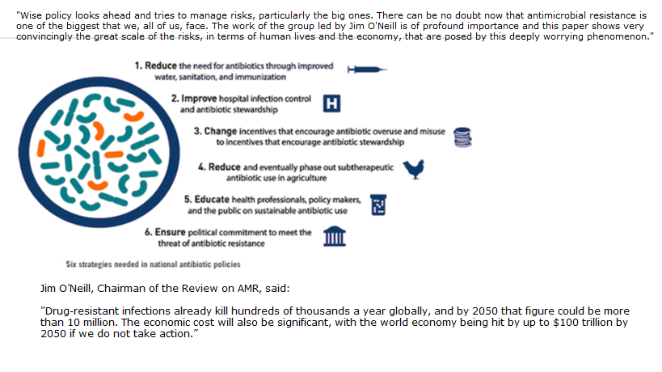Cutting out subtherapeutic antibiotics used for feed conversion in Poultry & Yearlings is a start, however it’s the day to day issues faced by the custodians that can influence change. Day to day mucus and skin issues being addressed by antibiotics alone is not sustainable and requires all owners, trainers & government ensure responsible stewardship begins today with sustainable antibiotic use.
The Government is funding clinical studies of Equine Salt Therapy across the three codes of racing ensuring that the technology will filter down into companion animals and other livestock. The progress of this will be comparable to Formula 1 technology like traction control & ABS that was developed for use in high performance vehicles that now applies as standard inclusions in everyday vehicles.
Start today by being a responsible antibiotic steward. Question the use of antibiotics as your role in protecting their effective use for times that they are actually required.
If you think of any application for my technology in the animal Kingdom please do not hesitate to contact me via the website: www.equinesalttherapy.com
Richard Butterworth

